MICRO TEACHING SELF-REFLECTION FORM
- Step 1 – Choose an area or two for particular focus
- Step 2 – Film your lesson (or part of your lesson)
- Step 3 – Watch the video and reflect upon it
- Step 4 – Watch the video again and make notes below
- Step 5 – Choose an element to share with a peer (it can be area that needs work or an area you are proud of)
- Step 6 – Re-plan, re-teach and then review again
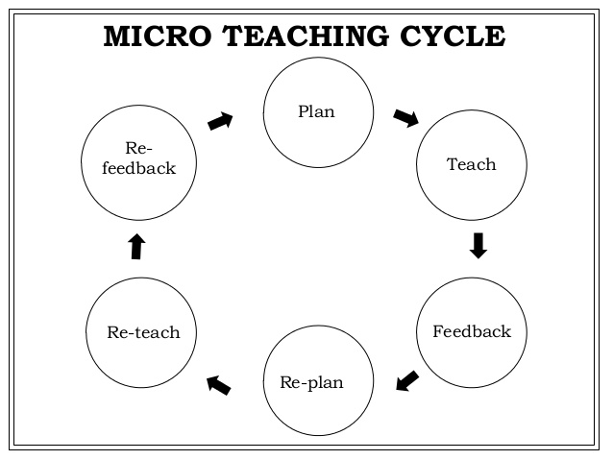
Area of focus (eg split screen lesson, questioning, differentiation, feedback )
Initial reflections on your presence in the classroom (Did you move? Did you have eye contact with all students? Did you smile? Did you praise students? Did you issue any commands or feedback without talking?)
Feedback on area of focus (How well did you implement the area of focus? How did students respond? Are the students being challenged and stretched? Do I use wait time effectively? How do I tie in the learning objectives? Have I set up a culture of independent learning?)
Which aspect of the lesson will you share with a peer/coach and why?
Further comments after having spoken to your peer

Remember being an expert teacher isn’t just about commenting on what happens, but also spotting what didn’t happen!

